Daily report

FEB : 20

Dimenzions

* Creating FB , Insta , linkdin, youtube , pages
* Profile optimisation
* Setting up A accounts
* Changed http to https
* Changed number and email in site

Hiring process

* Lead searching
* Linkedin messages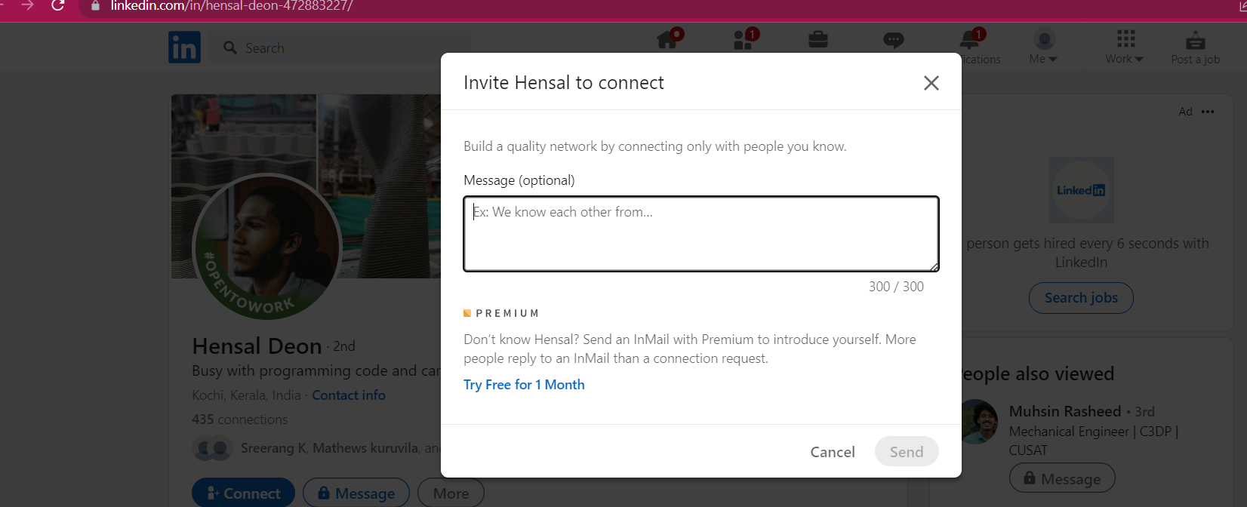

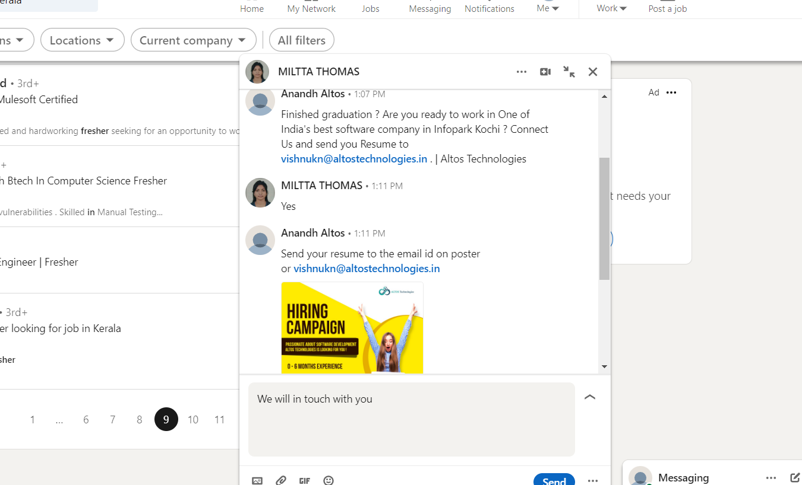

* Sending 50 and collecting resumes

As you can see, some linkedin is the best place to get a job and to post a job . so we mainly focus on linkedin . And also we can't directly message anyone but the option “connect” has a “add note” option . We fill our details in short in order to get what we want .

List of linkedin submission : <https://docs.google.com/spreadsheets/d/1DXGgA_JiagTQllkPdAsRykX5Rc7m8_yzXFNwsBEo90I/edit?usp=sharing>

This is the list of persons whom i send message as note.

Feb 21

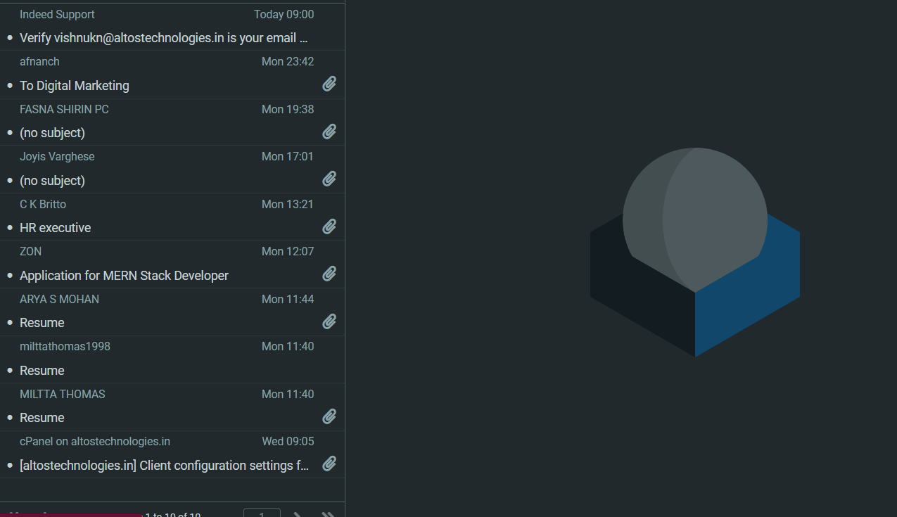

Continuing the job hiring and internship process.

* Added post on Hirewalk
* Looked through b.com graduates who fresher for digital marketing hiring
* Preparing hiring post

On the first day we expected 50 leads . But unfortunately we received 8-11 leads on 20th feb

As continuing the in 21 , Opening Hiring walks and other job posting websites and posting for the positions .

Posting On social medias , stories and etc…

Youtube marketing

* Removed Malayalam audio videos.
* Added more tags in youtube videos
* Title change

Youtube market via Telegram

* Placing links in groups , crack and apk groups , job groups , Lets see after 4 days .

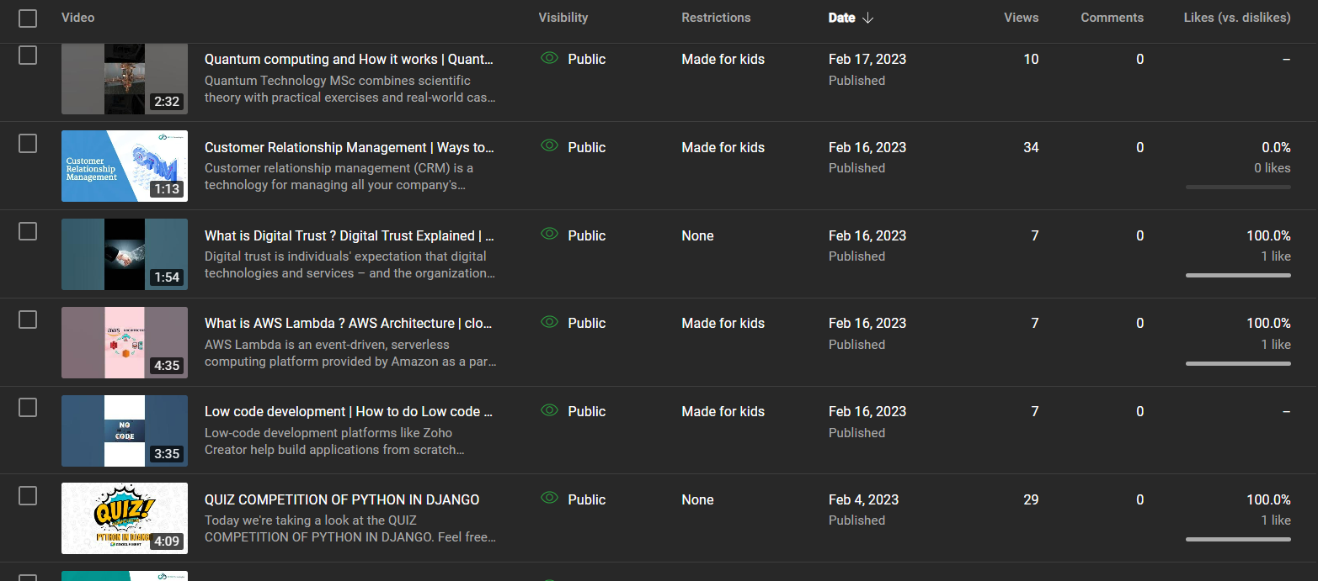

The present youtube views . 21/02/2023

Feb 22

* Added social media posters to Altos about Hiring and Intersnhips.
* Analysed linkedin and it is seemed that more than 35 applicants has been applied from linkedin .
* Facebook shering has been bought 7 applicants .
* Tried to look into backlinks for Dimezions and only 5 made because i use backlink [vishnuknwork@gmail.com](mailto:vishnuknwork@gmail.com)
* Analysed views in Hirewalk but didnt get anything as expected .

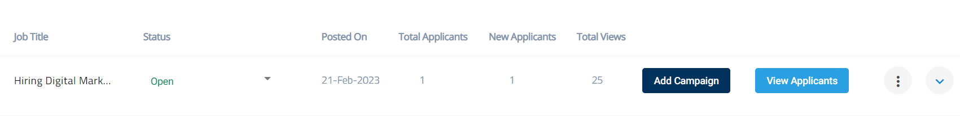

25 Applicants has been viewed and 1 Applicant has applied for digital marketing

* Creating a job post on Hirewalk of react Js , Python Devloper and internship
* Linkedin altos page had a free job post and Diigtal marketing hiring was given as a test run and It gave 35 applicants in 22feb -23 feb morning .
* 

Uploaded social media posters

Feb 23

Youtube marketing

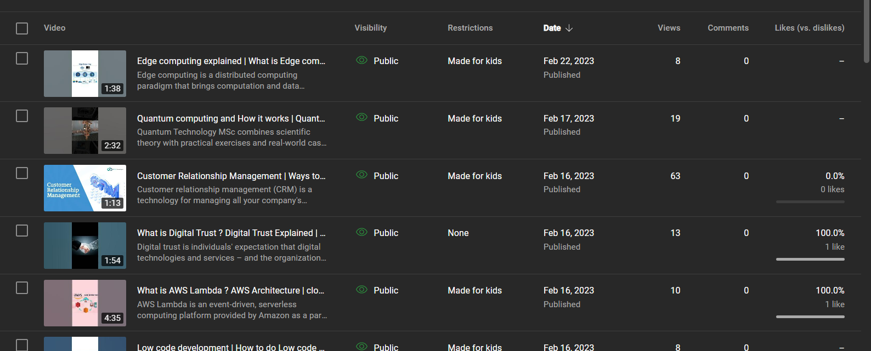

Last time on 21 st I had changed the tags and two or three keywords in youtube videos last i uploaded and CRM video most video views than other videos .

* Continuing youtube marketing via telegram ad other social media platforms.
* Creating and posting hiking posters and
* Uploading Dimezions services posters. And inviting others to follow
* Creating backlinks
* Add notes to linkedin

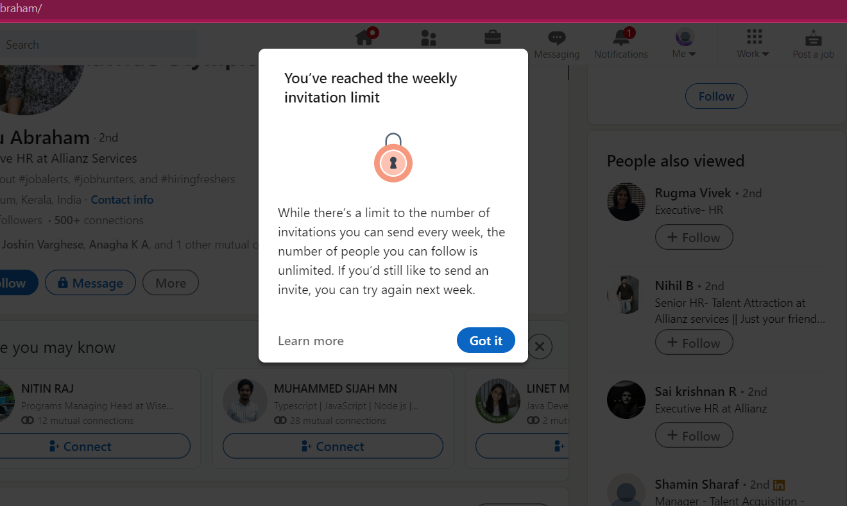

As i doing that unlimitedly , My weekly invitation link has been reached and Add note method is not available now.

* Checked on webmail 55 has crossed
* Promotion through posters in social medias fb groups etc
* Creating backlinks
* Adding service posters to dimension
* Sending invitation links of both altos and dimension to increase the audience

view in both fb and linkedin .



Uploaded social media posters

FEB 24

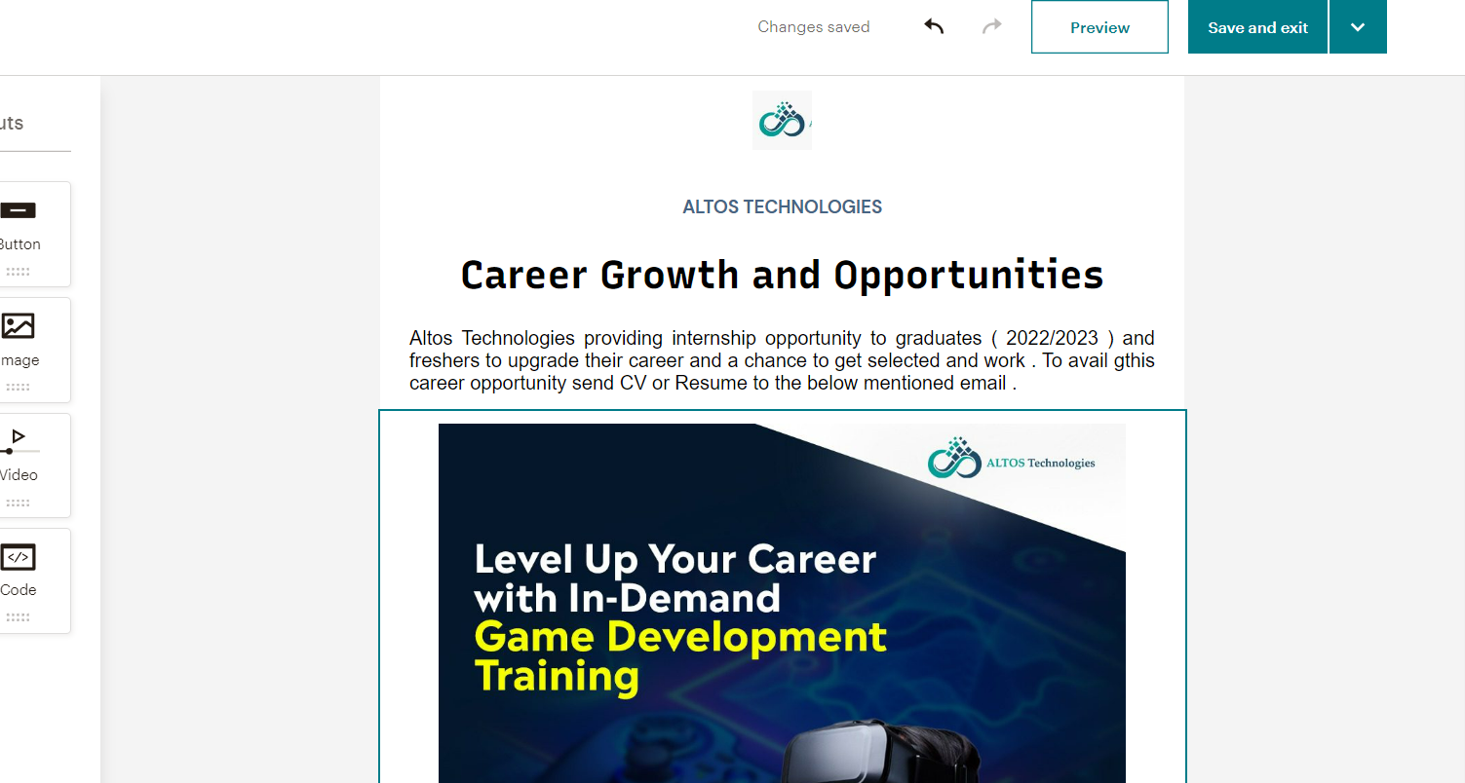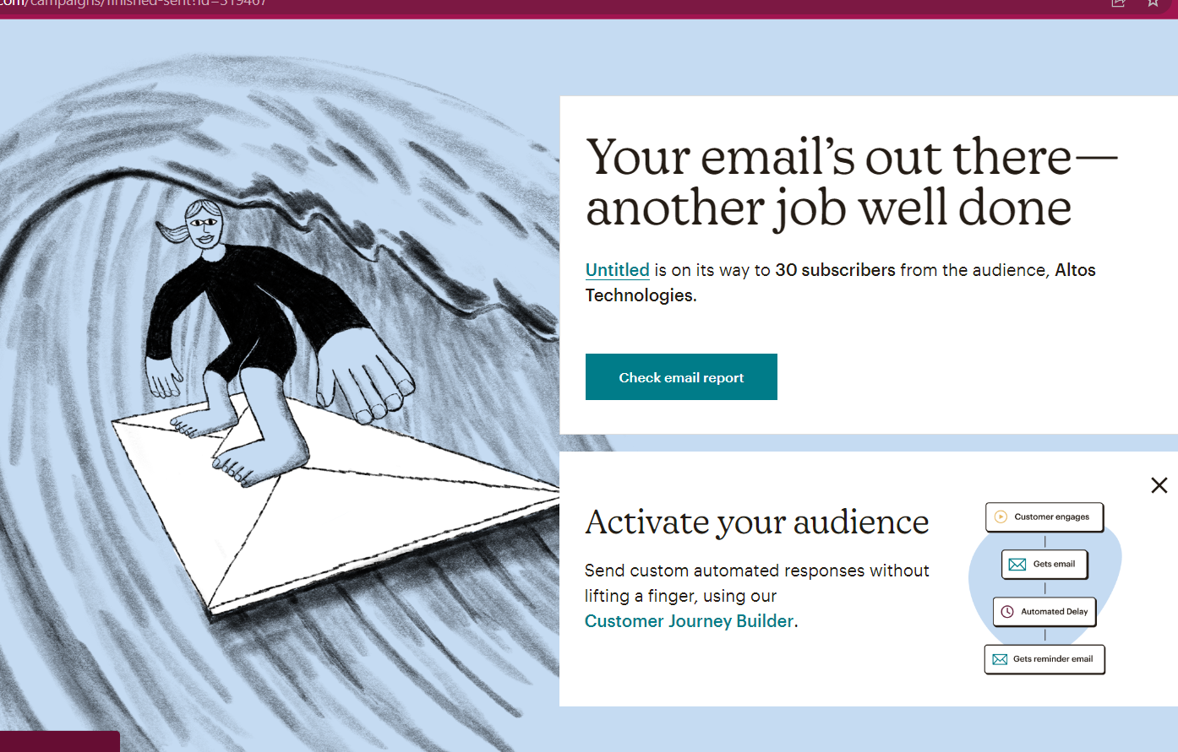

An Emails about our internship programme has been sent to colleges official emails .

The colleges are located in different cities and different locations as per discussed . The email has been gone to colleges official emails , so doesnt need to expect that much reach.

* Making freelancers and other company knowing that dimenzions providing a opportunity to work with us for that
* Searching freelancers in Kochi and Kerala
* Searching 3d modeling freelancers in Kerala
* Architecture firms and freelance architects
* etc…….

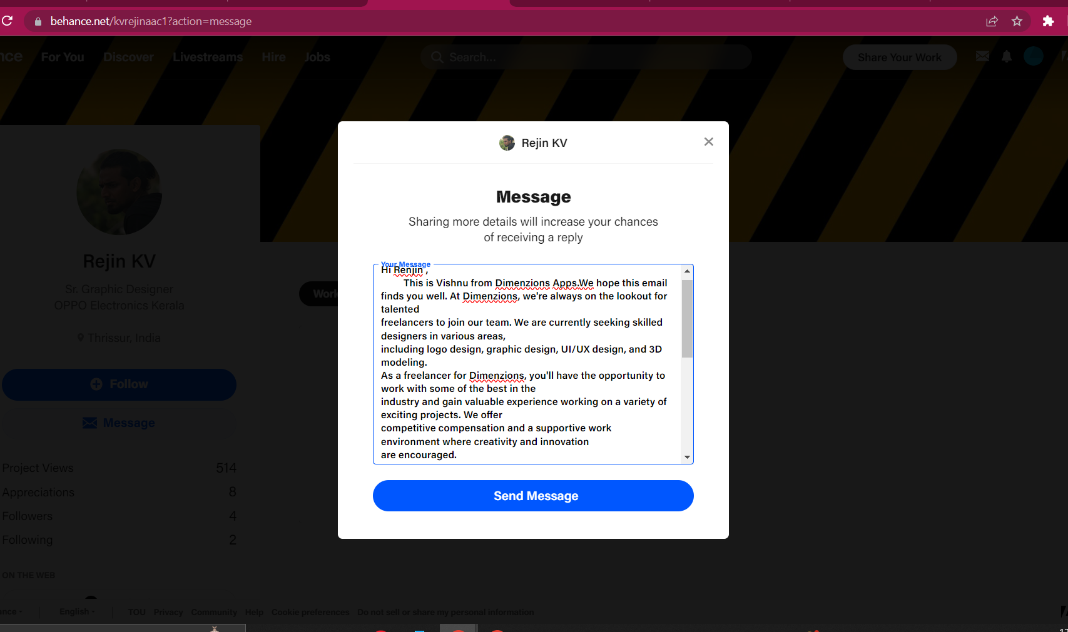

Dimension apps freelancer hiring for graphic designer has been sended on adobe . The list of persons sended has mentioned . The limit of messege also has reached so i couldnt send further more.

Email and Phone number of freelancers are colled on feb 24

https://docs.google.com/spreadsheets/d/17GpqwmozHGKDzw5aEJBdGXHyUvgwYCQmbld5cFDyeDc/edit?usp=sharing

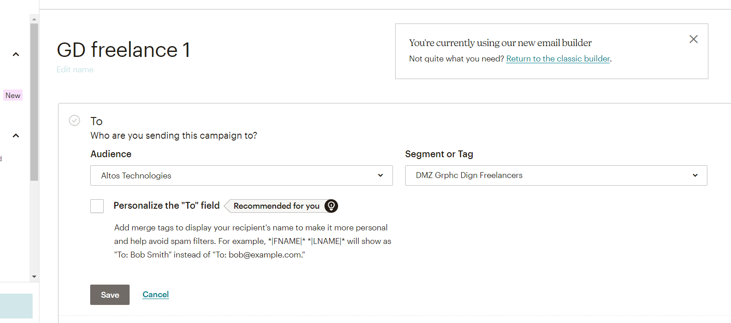

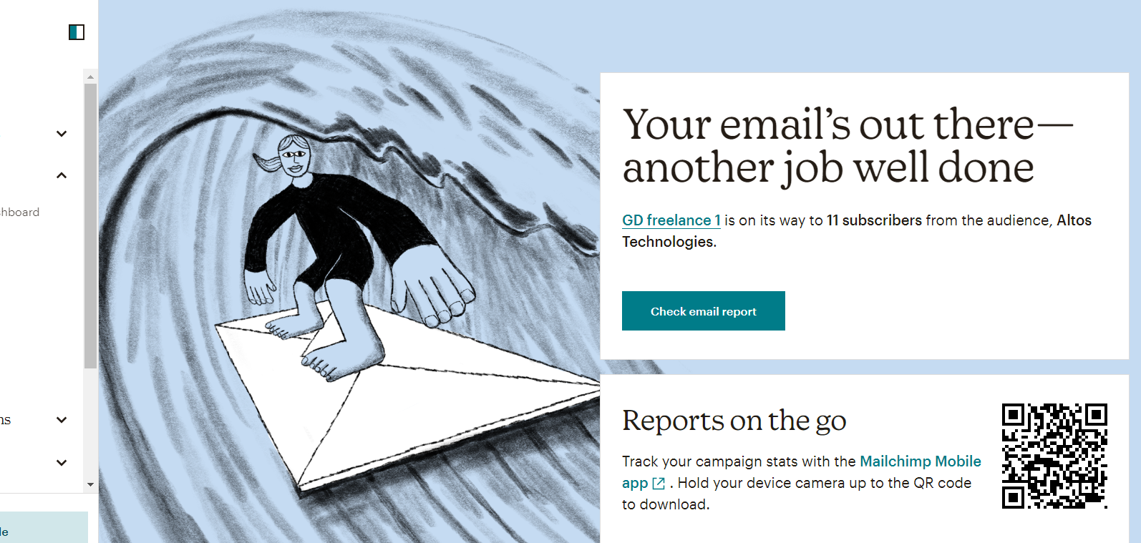

Email sent to Graphic designers from mail chimp .

Feb 25

So by checking overall performance



This is the post before 10 th feb 2023

And its details

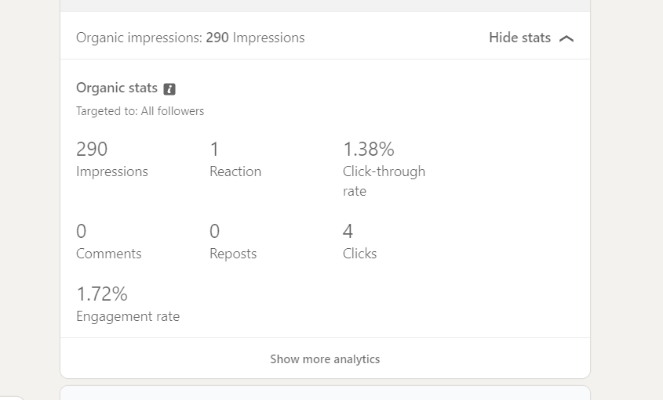



This the poster of our hiring process whichStarted this week

And its details

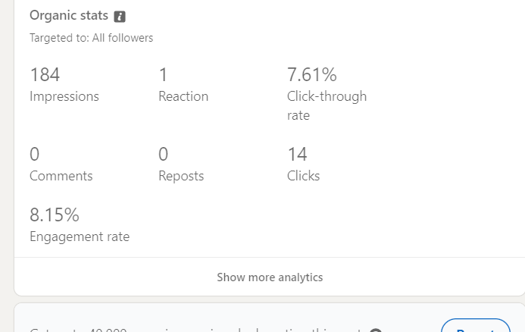

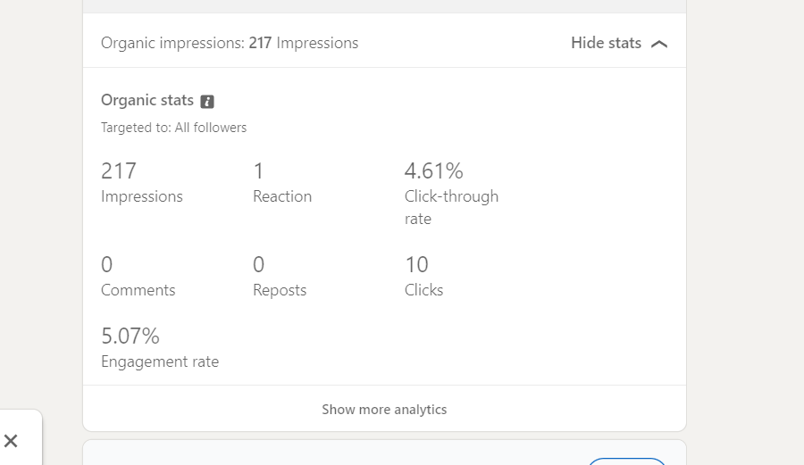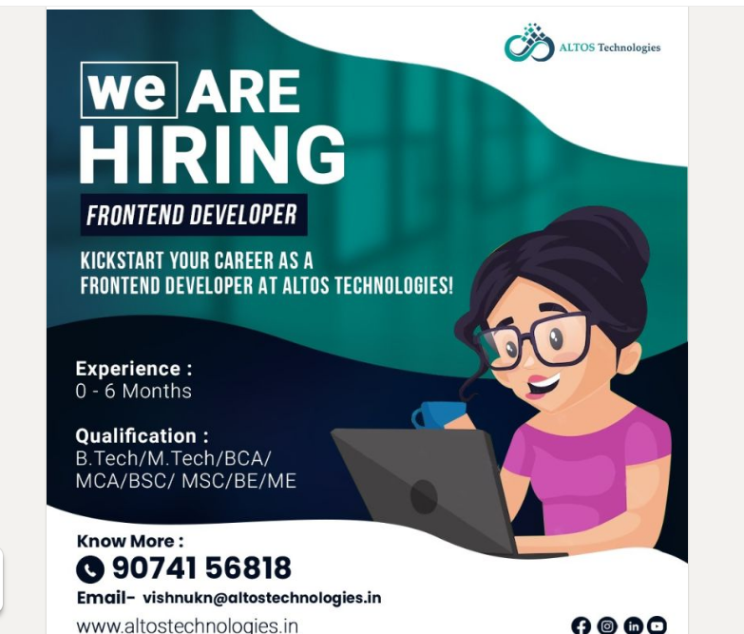

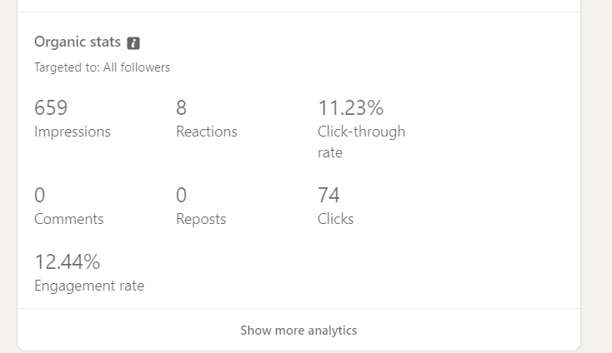

Then overall performance of the hiring process is much increased

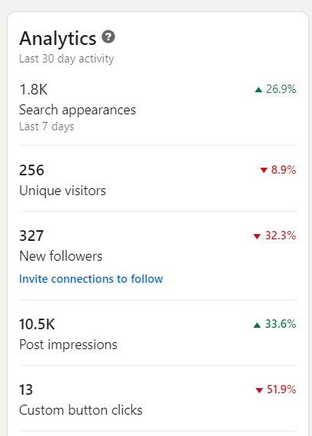

Our linkedin page analysis report says thaty search appearance is increased last time on 21/02/2023 was below 10% and its more than 25%

The Site altostechnologies.in

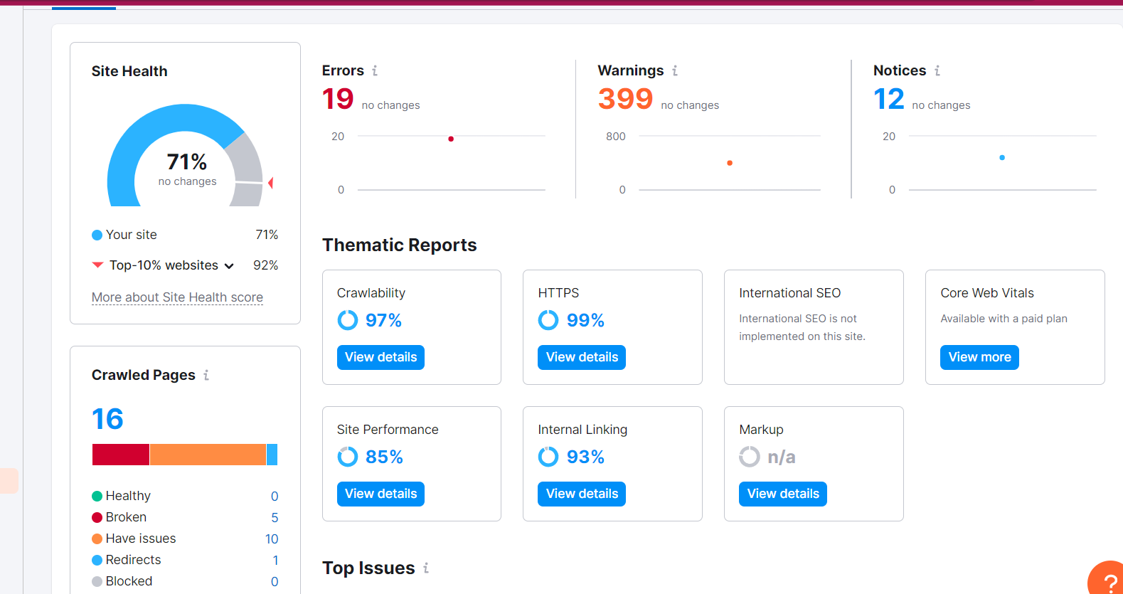

This is the site audit of 25/02/2023

This is the site audit of Feb 18th

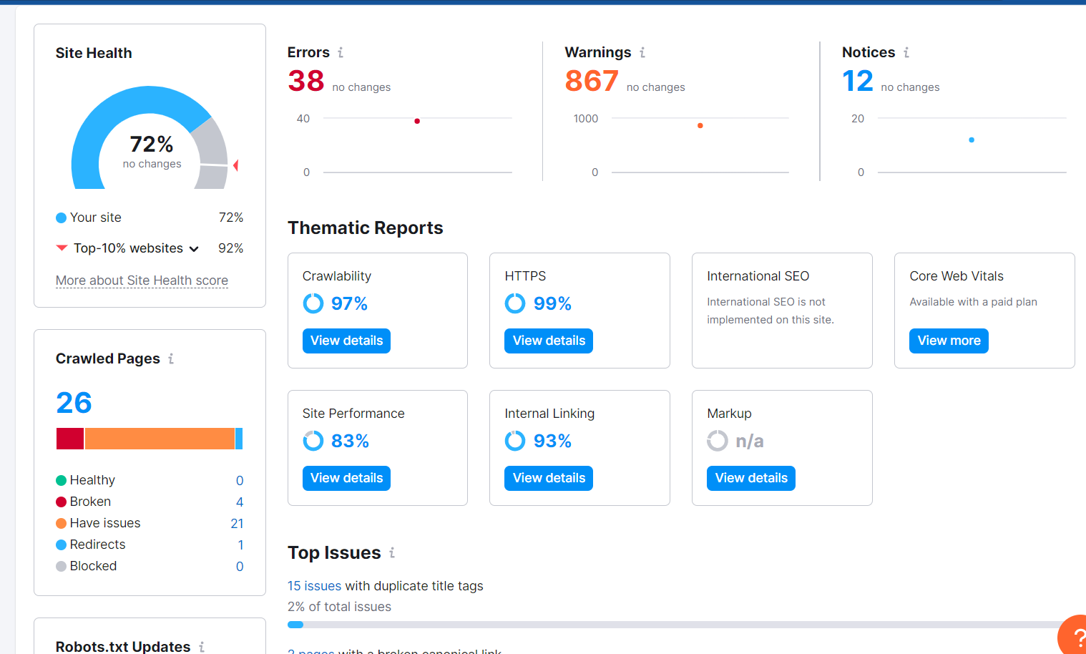

As you can see the site performance is increasing that its errors and warnings are decreasing .

But

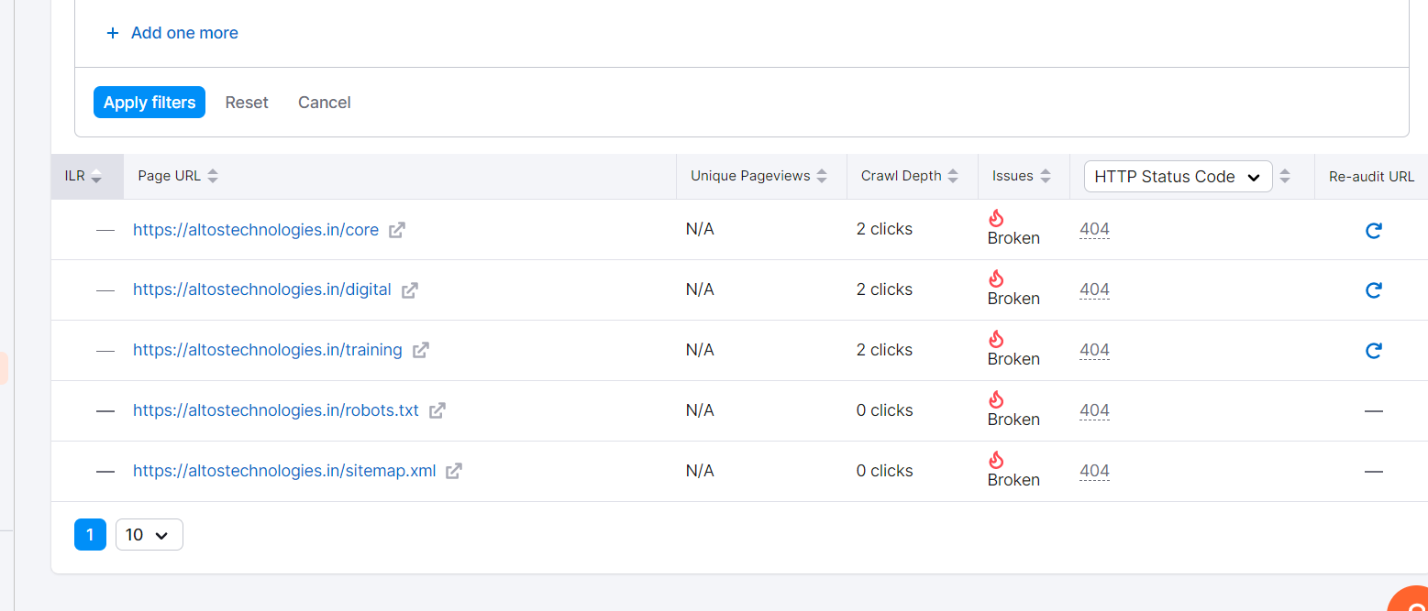

Expect other errors we have 5 broken links and 2 are still unrecoverable issue

* SITE MAP
* ROBOT.txt

We are still finding solution for that

Dimenzions

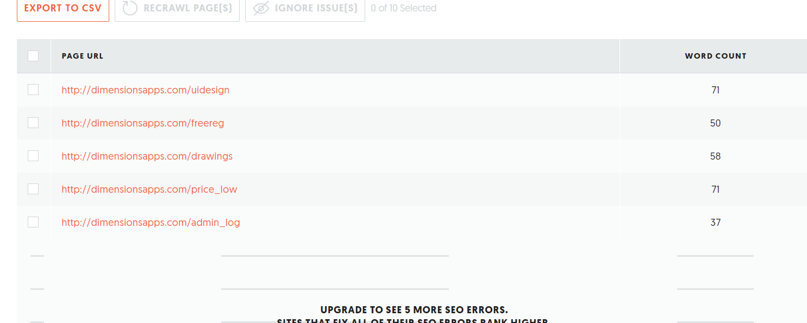

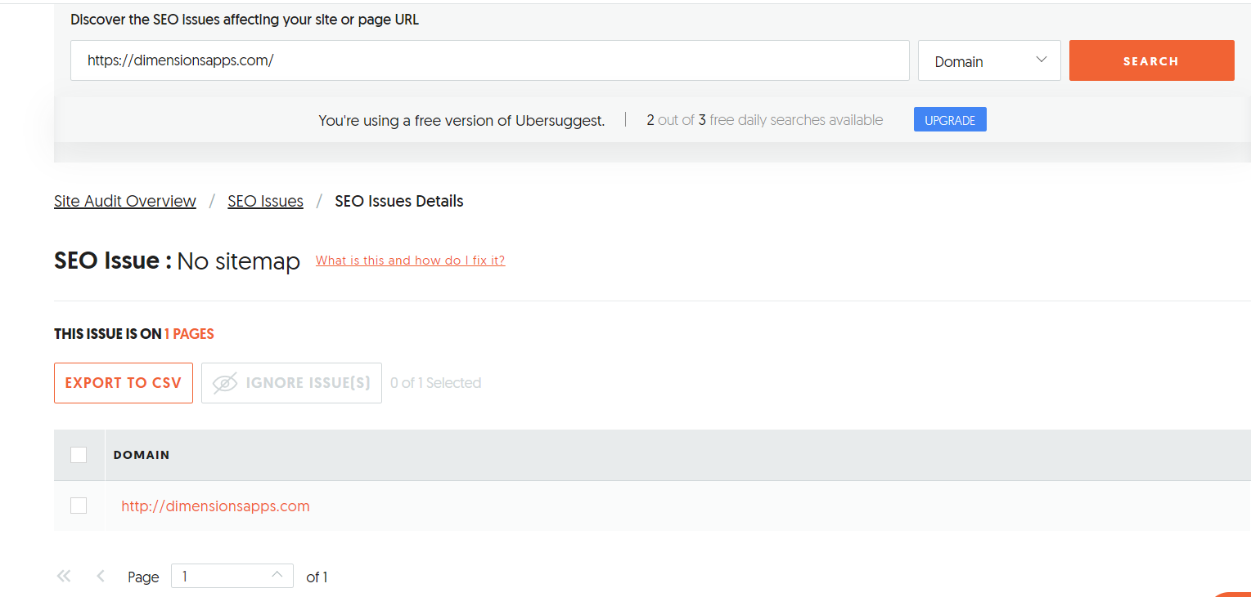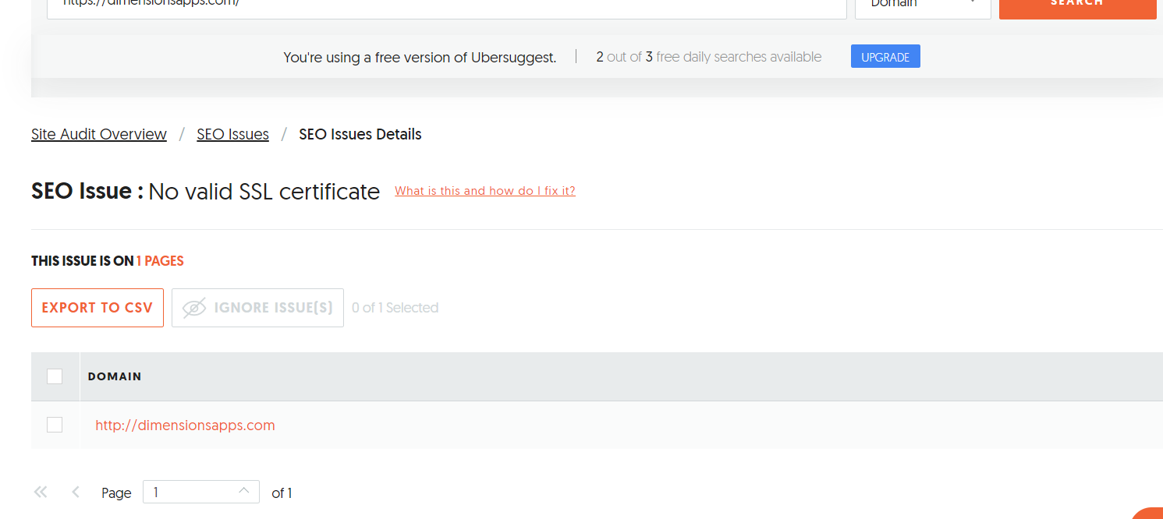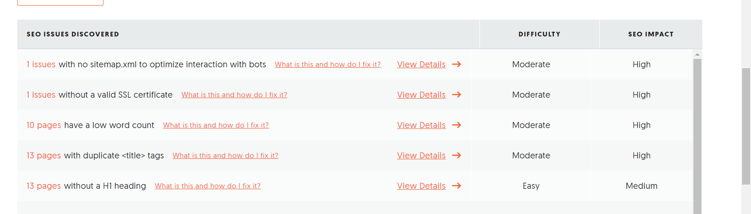

These are the issues found on Dimenzions site audit

The solutions

* Valid SSL Certificate providing
* Sitemap
* Keywords adding and content increasing
* Duplicate tags doesnt need to be considered
* H1 providing

These are all for dimensions at now

We can see the overall performance at month end.

Youtube



The youtube channel of Altos Technologies videos on 24 th feb 2023

&

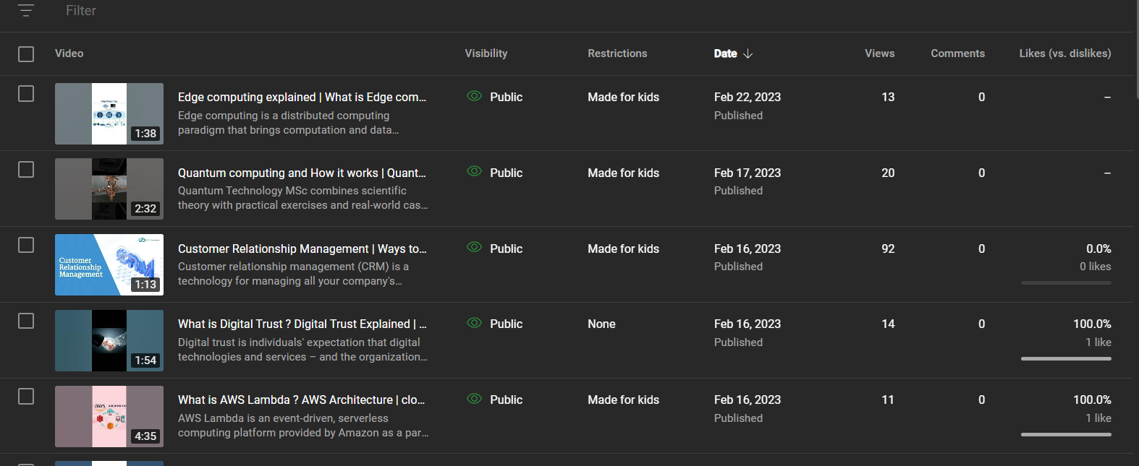

The youtube channel of Altos on 25th feb 2023

As by using telegram for increasing views , the views for CRM is mainly increased .

I have mainly focused on CRM because other videos were in post and delete and CRM was the main thing which was creating more reach

Other channels are going to be focused now .

Negative report on Hiring process

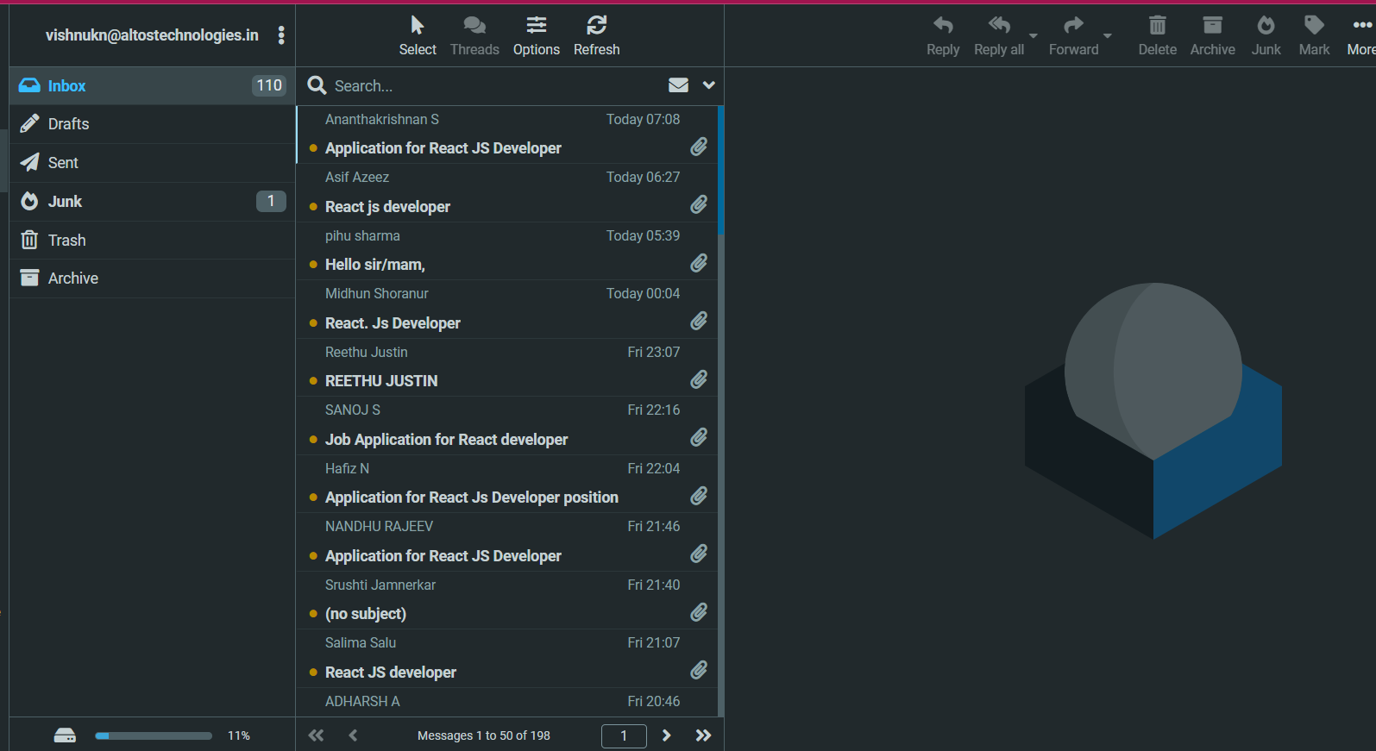

This is the overall [performance from 22/02/02023

I was told to bring 50 leads per day but I couldn't get as expected . I will be focused to bring Hiring and Internship process more than expected

This is the overall weekly report as I conducted